**Algorithm explanation**

Initially, I let R0 store the value which is stored at x3100, let R1 store the value x000F, let R2 store the answer, let R4 store the value xF000. To check if R0 contains 4 continuous 1, I firstly let R3 equal to R0 **AND** R1 to see if the result equals to x000F, secondly let R3 equal to R0 **AND** R4 to see if the result equals to xF000. If one of the result is TRUE, then it means R0 contains 4 continuous 1 and the program skip to R2=1 and halt the program. If both the result is false, then I create a loop. First, I let R1 = R1 + R1, which is equivalent to moving the binary number of R1 one bit to the left. Second, check if R1 equals to xF000. If the result is true, that means every possibility is checked out and the word does not contain 4 continuous 1. The loop terminates and the program skip to HALT. If the result is false, the loop continues to check if R3(R3=R0 **AND** R1) equals to R1. If the result is yes, set R2 equal to 1 and terminate the loop and halt the program. Else, skip back to R1=R1+R1 and continue to cycle.

**Essential parts of your code with sufficient comments**

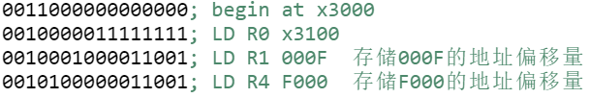

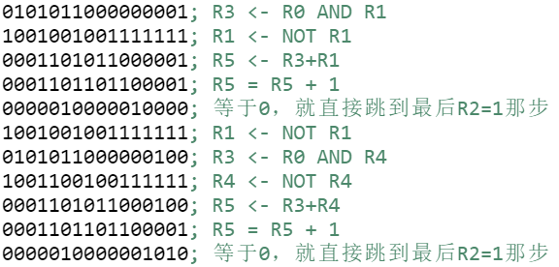

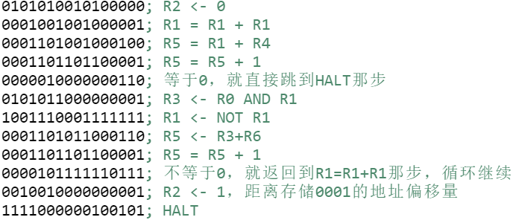

**Questions TA asked you and your answer in Check**

**TA:**What is your approach to this program?

**ME:**First I let R0 store the word which is needed to be checked and let R1 store x000F and let R4 store xF000. Then I check if (R1 AND R0 = R1) or (R4 AND R0 = R4), if one of them is true, set R2=1 and terminate the program. Else I create a loop, each cycle makes R1 twice as large and makes R2 equal to 0 and check if (R1 AND R0 =R1). If the result is true then set R2=1, terminate the program and the loop. Else if R1 = xF000, terminate the loop and halt the program.